Add employees function  
Service assign function

In this sprint, we have added 2 important functions such as Adding Employees and Assigning Services to Employees. First of all, Adding Employees function, we have made it for now, only admin is able to add new employees. The data which are gathered from FrontEnd will be transferred into BackEnd and will be processed to be inserted into MySQL Database. If the employee is already in the database, it will display error and will not process the data into BackEnd at all. Secondly, the Assigning Services to Employees function, in the page, Admin will see all employees which are already registered into database on the page. After Admin selects an employee, they will be able to assign jobs to the employee and after assigning them, it will be transferred to BackEnd to be processed into database. From there, when employees open their dashboard, it will display their job and automatically list all of their duties for the day and the next day.

**Add Employee Codes**

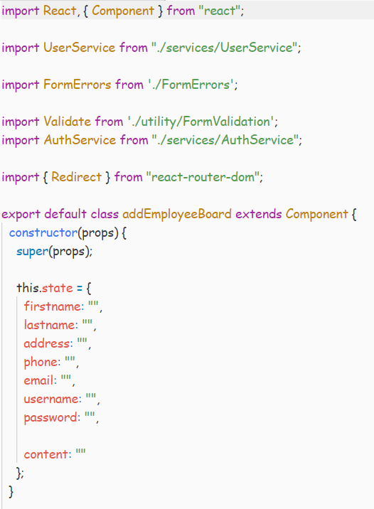

**Picture 1.1** Constructor

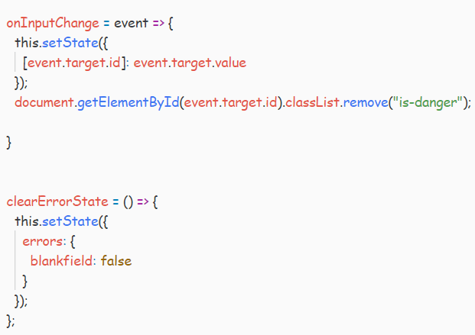

**Picture 1.2** Input Checking

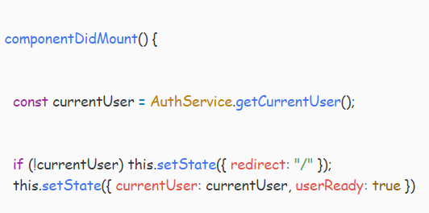

**Picture 1.3** If the user is logged in.

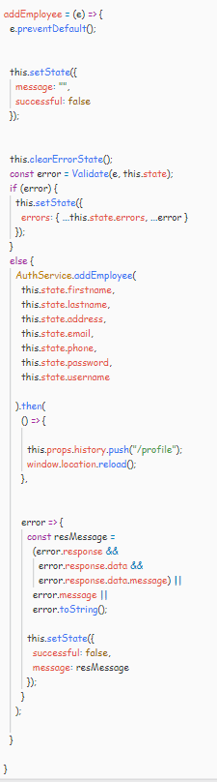

**Picture 1.4** addEmployee for Adding Employee methods.

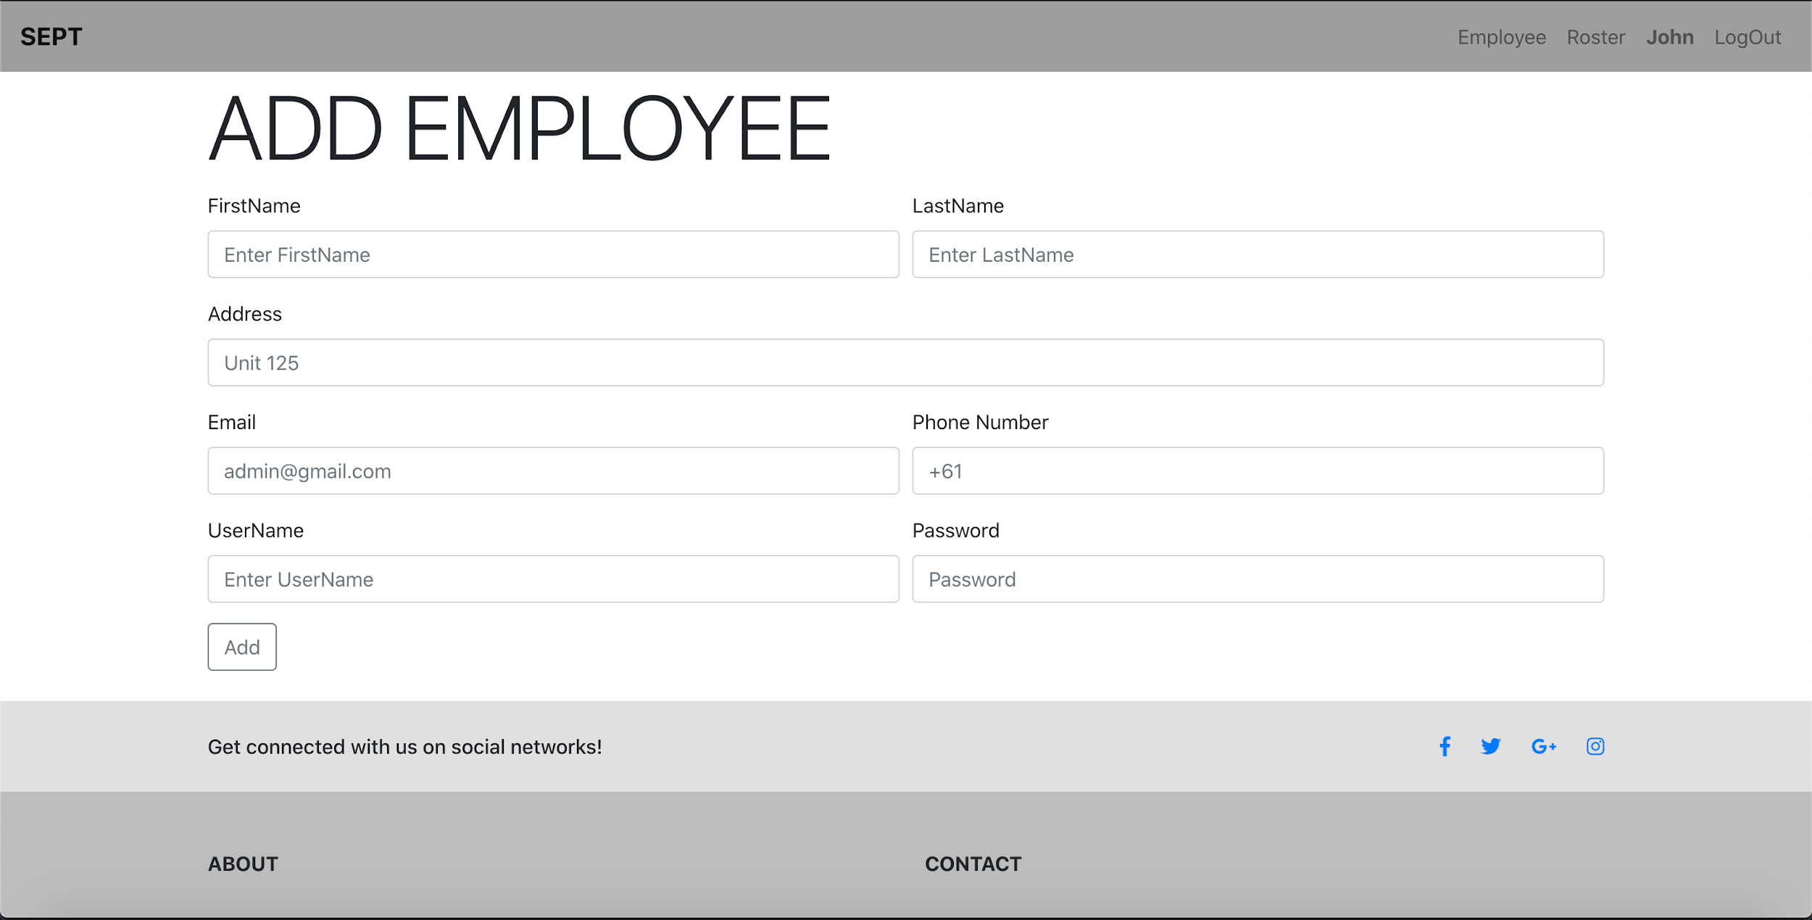

**Picture 1.5** Add employee page in front end

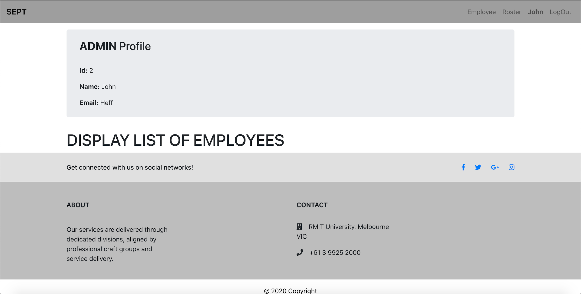

**Picture 1.6** admin page displaying list of employees.

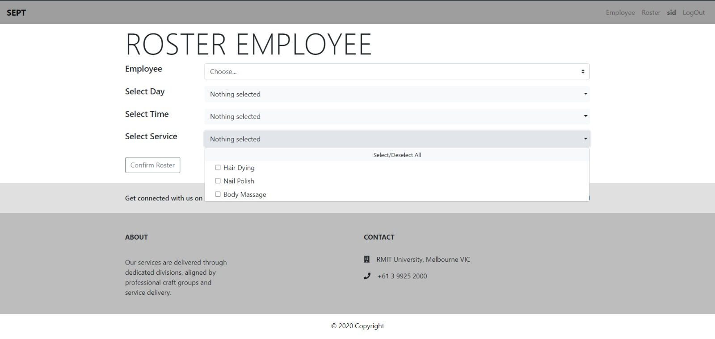

**Picture 1.7** Admin page allowing to add employees to the roster